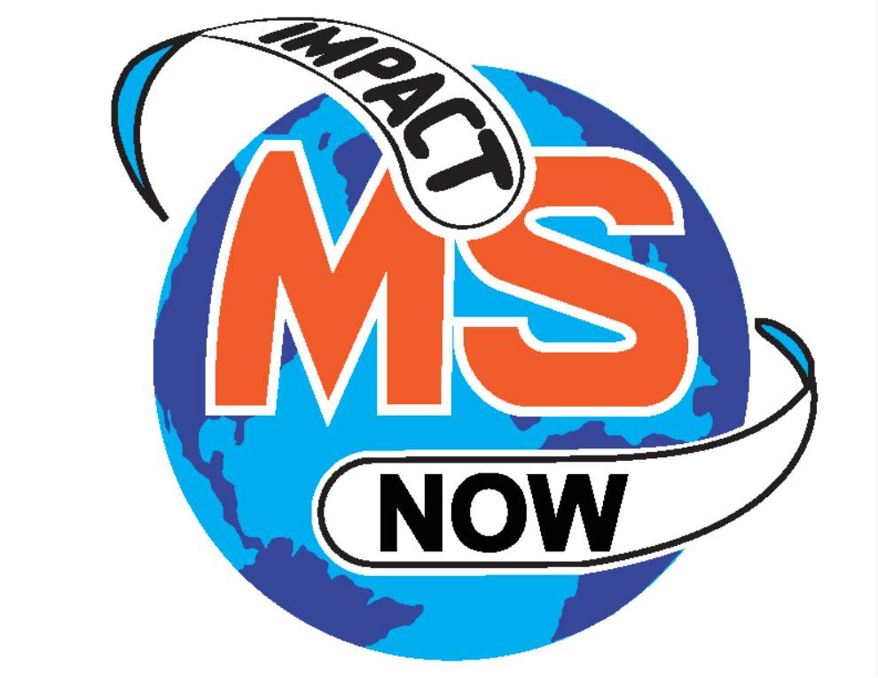
Educational Scholarships

Prior to founding ImpactMS Now, we were, and still are, associated with the National Multiple Sclerosis Society. Our initial, and ongoing, goal is to raise funds to find a cure for multiple sclerosis. Educational scholarships from the ImpactMS Now scholarship program helps highly qualified students achieve their dreams of going to college. Our goal in 2019 is to award 4 scholarships to students in our local community High Schools.

Overview
Enrollment for the 2019 scholarship program is open between October 1, 2018 and February 28, 2019. Please see below for eligibility criteria, frequently asked questions and link to the application.

Scholarship Application
Applications are accepted by mail only.
Full scholarship program information, including application, details, timelines, guidelines and resources, can be viewed under “frequently asked questions.
Support for the scholarship program comes from sponsorships, foundations, individual donors, fundraising events and other sources.

FREQUENTLY ASKED QUESTIONS

Is there an application fee?
No, we do not charge students to apply for this scholarship.
How many scholarships will be given?
We are granting a minimum of four (4) scholarships for the graduating class of 2019. The application review and selection process is competitive and not all applicants will be granted an award
Who is eligible?
- High school seniors who will be attending an accredited post secondary school for the first time with an overall GPA of 3.50.
- Applicants must be active in their community, volunteering 15 hours to non-profit organizations per semester. Applicants must provide a letter from non-profit organization verifying hours.
- Applicants must submit one-page essay on multiple sclerosis and how it affects individuals (applicants need to provide source materials if used).
- Applicants must attend high schools in Denton or Wise counties.
- Applicants must be United States citizens or legal residents, and plan to enroll in an undergraduate course of study at an accredited two- or four-year college, university, or vocational-technical school located in the U.S.
- Students who are planning a mission trip, GAP year, or other experience and do not plan to enroll in college for the 2019-20 academic year should not apply now. Instead, apply in the year you plan to enroll in college.
- Enroll in at least 6 credit hours per semester in coursework leading to a first-time degree, license or certificate.
- Students who have already completed an undergraduate degree are ineligible to apply.
(ImpactMS Now reserves the right to review the conditions and procedures of the scholarship program and make changes at any time..)

Why are there limits on who can apply?
While we know that there are many qualified and worthy candidates who could benefit from financial support for educational endeavors, support for scholarships is only one part of ImpactMS Now’s overall mission. There are funding limitations and costs associated with collecting and reviewing each application. A larger number of applications mean larger administrative costs for the program, and more potential students taking time to fill out applications who will be disappointed. A volunteer committee of business and community leadership will review the applications and determine the finalists based on the eligibility criteria. The application review and selection process is competitive, and not all applicants will be granted an award. Please check back each year as eligibility criteria may change.

Must I plan to be a full-time student?
We understand that full-time study is not possible for everyone due to health concerns or family care responsibilities. You must be enrolled for at least six credit hours per academic term to be eligible as a part-time student. The scholarship is intended for students who are pursuing a degree, license, or certificate and is not for those who want to take an occasional personal enrichment class.

I want to go to a technical school and not to college. Can I apply?
Any postsecondary, undergraduate school is fine as long as it meets national, state, or professional accreditation standards. You must plan to attend school at least part-time – six credit hours per school term. You can verify a school's accreditation status by accessing the U.S. Dept of Education's Database of Accredited Postsecondary Institutions and Programs at https://ope.ed.gov/accreditation.
What’s the deadline?
The deadline to submit your online application is February 28, 2019.
I missed the deadline – can I still apply?
Late applications will not be accepted. Please plan to get your application in early to avoid unexpected delays. There will be no exceptions.
Can I apply again next year?
If you received an ImpactMS Now scholarship in 2018 for the 2018-19 academic year, you may not reapply for a subsequent award. Please understand that funds are limited and awards are never guaranteed. Please check back each October to see if our eligibility criteria has changed.
Can I renew my scholarship?
Scholarships cannot be renewed.
Will scholarships be given out every year?
ImpactMS Now reserves the right to review the conditions and procedures of the scholarship program and make changes at any time including discontinuing the program. Visit www.impactmsnow.org periodically for updates.
Where does the money for scholarships come from?
ImpactMS Now hosts community events to raise funds supporting the scholarship program. We have a wide variety of donors that include corporate donors, foundations, sponsorships, board members and volunteers of ImpactMS Now.
What are the criteria for selecting finalists?
All applicants must meet the basic eligibility criteria, print and fully complete the online application and mail all supporting documents by the February 28, 2019 deadline. The program is competitive in nature, and not all applicants will be selected for an award. Scholarship finalists will be selected based on academic record, leadership and participation in school or community activities, and an essay written by the applicant. The selection process will not be influenced or affected by the actual or perceived race, religion, color, national origin, ancestry, disability, gender, age or sexual orientation of any applicant. In addition, donations to ImpactMS Now or pre-existing relationships with ImpactMS Now are not part of the evaluation of student merit.
Who selects the recipients?
ImpactMS Now will receive all applications and carefully disburse to Review Board. Review Board will consist of Business and Community leadership, volunteers and donors. ImpactMS Now makes final award decisions.
How and when will I be notified if I receive a scholarship?
Once your application is received, you will be notified by email confirming acknowledgement of your application. All applicants will receive a letter by April 1, 2019 to let them know if they have been selected as a recipient or not. Add impactmsnow@impactmsnow.org to your contacts to ensure you receive future notices and check your junk folder if you don't see it in your inbox. Communications with all applicants is done by paper mail, email or both. Please be sure to check your email regularly. If you have any changes to your email or your postal address, please email us at impactmsnow@impactmsnow.org
What will be required of me if I am selected to receive a scholarship?
You must complete and submit a signed Scholarship Acceptance Form before funds can be processed. You must notify your school about the award and deliver the scholarship checks to the school in a timely manner. You will be asked to email a current photograph and write a thank you note to at least one donor. You are required to notify impactmsnow@impactmsnow.org of any change in address, school enrollment or other relevant information and to send a complete transcript when requested.
When will scholarship checks be mailed?
ImpactMS Now will issue a check in one installment on August 1st. The check is mailed from ImpactMS Now to each recipient's home address and is made payable to the college for the student's account.
What if I don't know where I will attend school?
List the school that you plan to attend. If you are applying to more than one institution, indicate only your first choice. If chosen as a scholar, you will have the opportunity to change your school information on the scholarship acceptance form that you receive with your notification letter. If your school information changes after you have returned your acceptance form, it is your responsibility to notify ImpactMS Now in a timely manner. Otherwise, you may expect delays in receiving your check. To update your account, email impactmsnow@impactmsnow.org
I have some questions about how to fill out the form – whom do I ask?
Email ImpactMS Now Monday-Friday, 8:00am-4:30pm central time @ impactmsnow@impactmsnow.org to assist you with scholarship questions.
Where can I get an application?
The application is available on this site (see top of page) on October 1, 2018. It will remain posted until the February 28, 2019 closing date.
If I don’t meet the criteria for ImpactMS Now Scholarship program, are there other resources available?
Yes there are. Below are resources that you may want to research.
Federal Assistance
- studentaid.ed.gov/sa/
  - The U.S. Department of Education’s Federal Student Aid (FSA) programs are the largest source of student aid in America.
- Fafsa.ed.gov
  - Free application for federal student aid
- Federal Student Aid Information Center
  - 1-800-4-FED-AID (1-800-433-3243)
  - This is a toll-free number.

